**EnRoute2.0 Assembling Instructions**

The EnRoute2.0 assembly comprises of various materials including MDF (medium density fiber), PVC(PolyVinyl Chloride) pipes, Acrylic.   
  
**EnClosure:**  
 *Dimensions*: 38.5” x 42.5” x 20”  
 *Materials Used*: 1/4” MDF and 1/4” Acrylic  
 *Assembly*: All the walls except the front of the enclosure were precisely cut using an electric saw due to dimensions exceeding our standard laser cutter bench,   
 The front of the enclosure is a combination of MDF framework and two 32”x16” clear acrylic sheets for ease of view of the HVAC testbed at work.

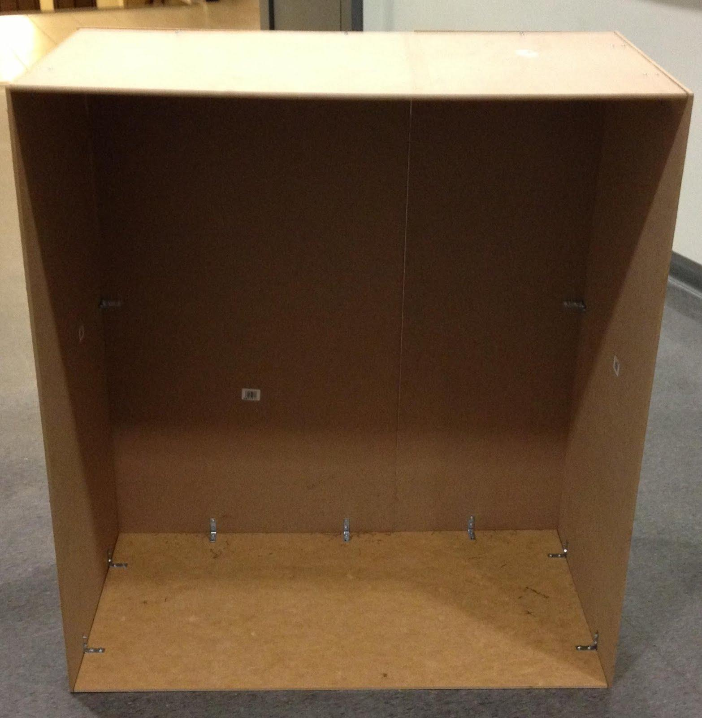

Fig 1 : Bare Enclosure

**Room:**  
 *Dimensions*: 14”x9”x14”  
 *Materials Used*: 1/4” MDF and 1/4” Acrylic  
 *Assembly*: The entire room was assembled from laser cut pieces, the CAD files for which can be found in our git repository. We also made small handles to easily remove the fronts when needed.  
 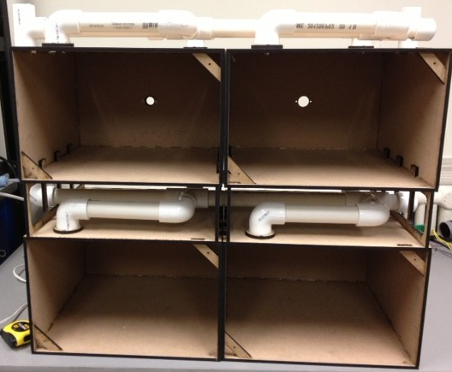  
 Fig 2 : 2 Zones 4 rooms

**Valves:**  
 *Dimensions*: Depending on what type of valve, the overall dimensions vary. However, the general stopping mechanism and the dimensions therein remain consistent in our system.   
 *Materials Used:* 1/4” MDF, 1/8” MDF, 1/8” clear Acrylic, plastic funnels.  
 *Assembly*: All the pieces except the shaft to the servo motor are press-fit. The Shaft assembly is a little tricky and contains a few very small pieces for a sturdy fit during rotation of the motor shaft. All these are available in the CAD files. We used funnels as a connector between the 1'' PVC pipe and the blower's inlet.

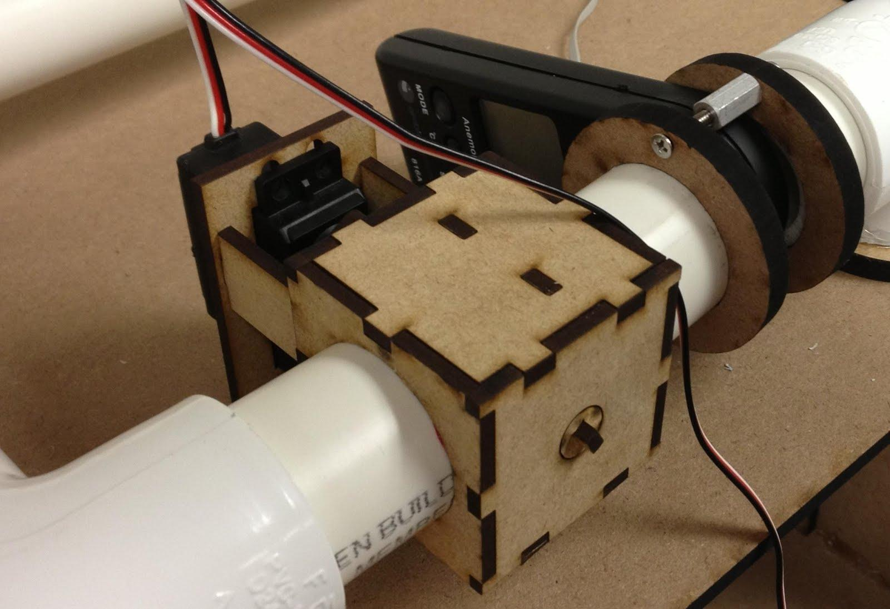

Fig 3 : Valve

**Duct Work:**  
 *Dimensions / Material Used:* 1” dia standard PVC pipe  
 We designed and placed all our components so as to have minimum ductwork for air to traverse.

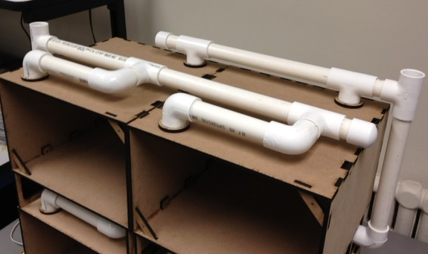

Fig 4 : Duct Work

**Cooling:**   
 *Materials Used:* Styrofoam box (13”x10”x11” ), Copper tubes (1” Dia, 2ft)  
 *Assembly*: The aforementioned copper was bent and the ends were used as inlet and outlet for the HVAC cooling system.

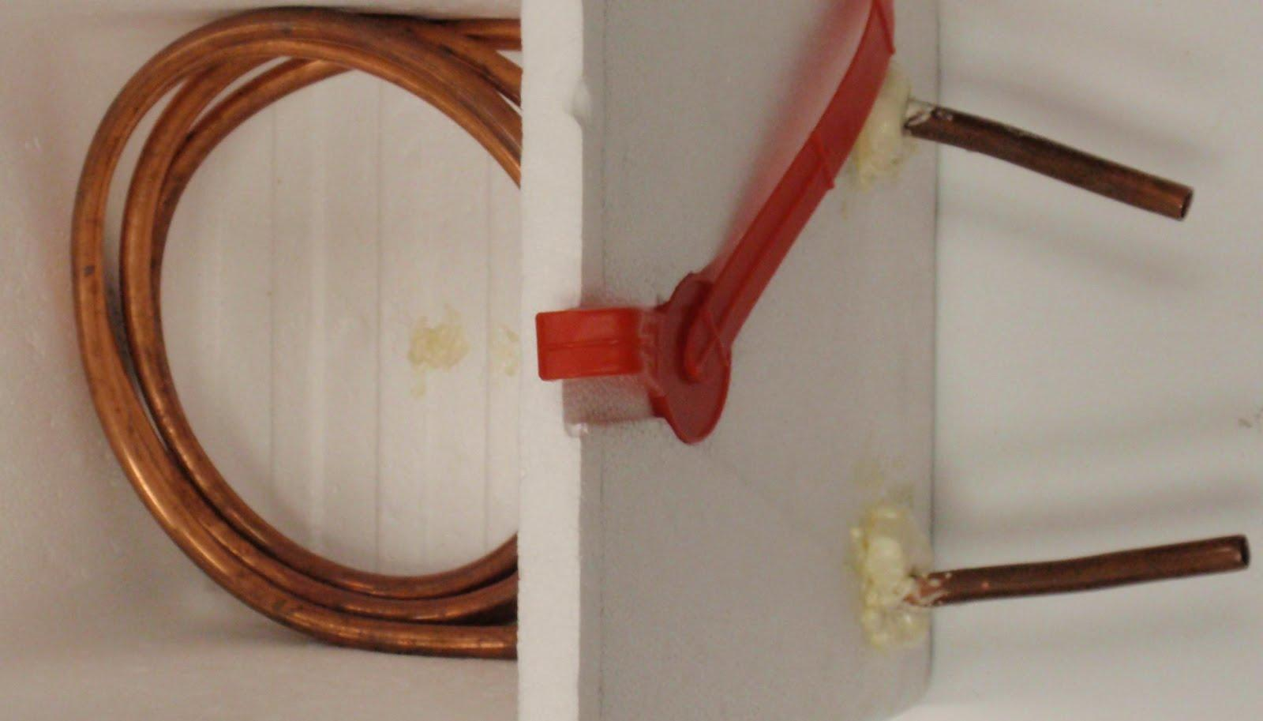

Fig 5 : Cooling box with Cu tubing

**Heating:**   
 *Material Used*: Hair dryer  
 *Assembly:* We used a funnel once again as a connector between one opening of the double valve and the inlet fan of the dryer. The outlet of the dryer was channeled to the main blower so as to heat the zones when required.  
   
 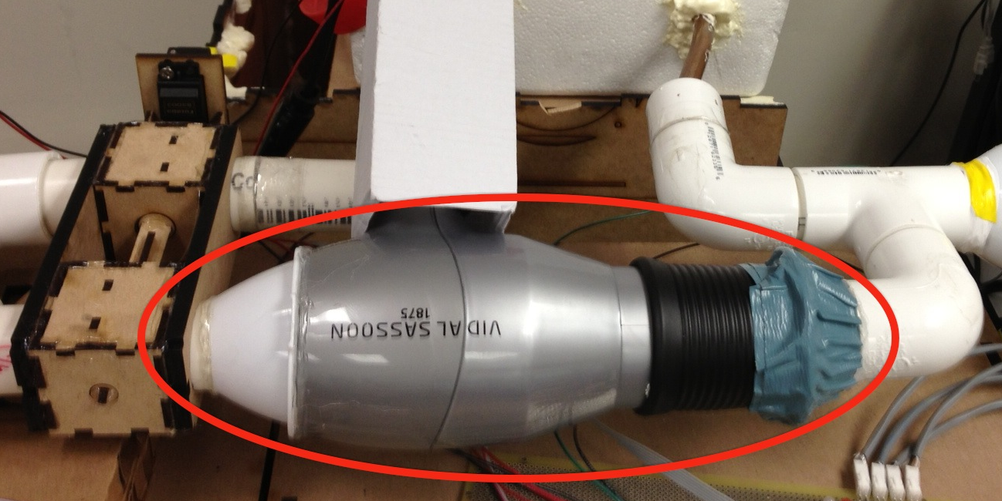

Fig 6 : Heating Mechanism with Double Valve